VySkan
Product Name | 4G LTE Ultra-Micro Pet & Asset Tracker
Product Model | VP-Pro
Ultra-Light. Rugged. Omnipresent.
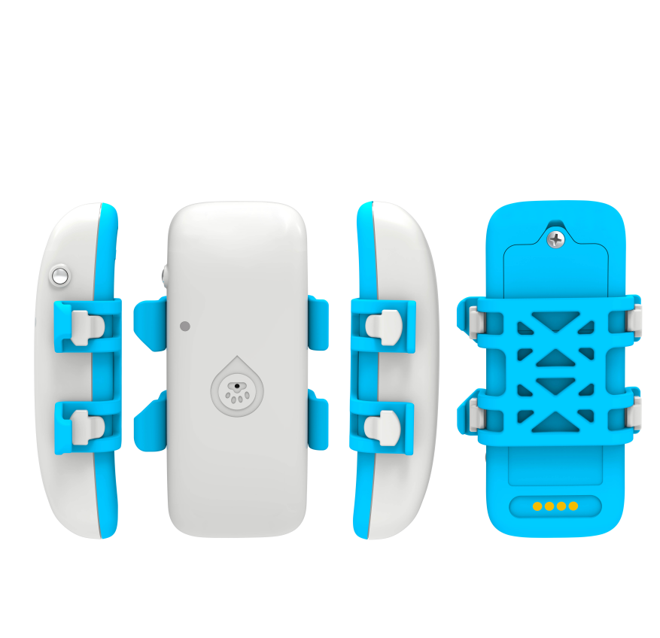
Engineered for high-value pets and discreet tracking, the Vyskan VP-Pro is an ultra-lightweight 4G LTE positioning terminal. Housed in a compact, IP67-rated ABS plastic enclosure , it delivers uncompromising performance in a mere 36g footprint. Powered by the EG915ULA communication module , it merges multi-mode positioning including GPS, BDS, GLONASS, WiFi, and LBS. Featuring a built-in 3-axis accelerometer for smart power management and dedicated "sound and light" seeking functions , it provides robust, real-time visibility for pets, personnel, and passenger vehicles.
- Core Value
- Five-Mode Precision & Zero Data Loss
Integrates GPS, BDS, GLONASS, WiFi, and LBS for pinpoint accuracy. A built-in high-capacity memory chip automatically caches trajectory data in wireless blind spots and uploads it when the network restores, ensuring no data is ever lost.
- Dynamic Smart Power Management
Driven by a precise 3-axis accelerometer algorithm , the device intelligently toggles between Continuous, Normal, Power-Saving, and Standby modes based on vibration detection. This maximizes the 700mAh polymer battery's efficiency.
- Active "Sound & Light" Retrieval
Equipped with an integrated buzzer and a white LED seeking light. Operators can remotely trigger audio-visual alarms to rapidly pinpoint the exact location of a lost pet or hidden asset in complex environments.

- Target Applications
- High-Value Pets & Working Dogs: (At just 36g, it ensures zero physical burden while the IP67 rating protects against water and dust during outdoor activities.)
- Personnel Monitoring: (The ultra-compact 51mm footprint allows for highly discreet carrying , providing real-time location tracking and vibration alarms.)
- Passenger & Fleet Vehicles: (Smart sleep/wake modes triggered by vibration optimize cellular data and battery life during transit.)
- Technical Specifications
  - Cellular & GNSS
Category | Specification | Description
Network Module | EG915ULA | Industrial-grade 4G module ensuring high stability.
Network Bands | 4G LTE-FDD &  2G GSM | Comprehensive coverage including LTE B2/B3/B4/B5/B7/B8/B28/B66 (Optional) and GSM 850/900/1800/1900MHz.
Positioning Mode | GPS+BDS+GLONASS+WiFi+LBS | Multi-layered constellation tracking for highly accurate indoor and outdoor visibility.
Startup Time | Cold: Avg 32s |  Hot: Avg 1s | Rapid Time-To-First-Fix (TTFF).
Sensitivity | -162 dBm | Maintains a strong satellite lock under challenging environmental conditions.
  - Power & Electrical
Category | Specification | Description
Battery Capacity | 700mAh(3.7V Polymer) | High-density battery optimized for long-term standalone operation.
Working Current | 60mA @ 4V (Avg) | Efficient power utilization during active tracking.
Standby Current | 5mA @ 4V (Avg) | Ultra-low drain during idle standby periods.
  - Interfaces & Expandability
Category | Specification | Description
Audio/Visual | Buzzer (1 Channel) & White LED | Supports remote sound and light seeking for rapid localized retrieval.
Sensor | 3-Axis Accelerometer | Enables intelligent wake-up and real-time posture/activity monitoring.
External Interface | Magnetic Port + Serial | Secure magnetic charging that prevents water ingress.
  - Physical & Environmental
Category | Specification | Description
Dimensions | 51mm × 40mm × 17mm | Pocket-sized and ultra-compact, easily adaptable for collars.
Weight | 36g | Exceptionally lightweight, eliminating carrying fatigue.
IP Rating | IP67 | Fully dustproof and highly waterproof for rugged outdoor deployment.
Operating Temp. | -20℃ to 75℃ | Resilient operation in diverse climates.

- Deployment & Integration
Zero-Hassle Deployment & Seamless Integration: The VP-Pro eliminates complex setups with an out-of-the-box magnetic charging system and a dedicated silicone collar attachment. It fully supports Over-The-Air (OTA) remote parameter configuration and online firmware upgrades. Administrators can effortlessly adjust reporting intervals, set virtual geofences, and receive real-time alerts directly via the global positioning service platform , streamlining integration via TCP/IP data transmission using domain or IP address connections.
- A personalized service prepared for you
- 1× VP-Pro Sample Device (Pre-configured)
- Full API & Protocol Documentation
- 1-on-1 Technical Support from our Field Engineers
- Contact us
Website: https://vyskan.com/
Email: marketing@vyskan.com

